Introduction to Transformers | Transformers Part 1
What is Self Attention | Transformers Part 2 | CampusX
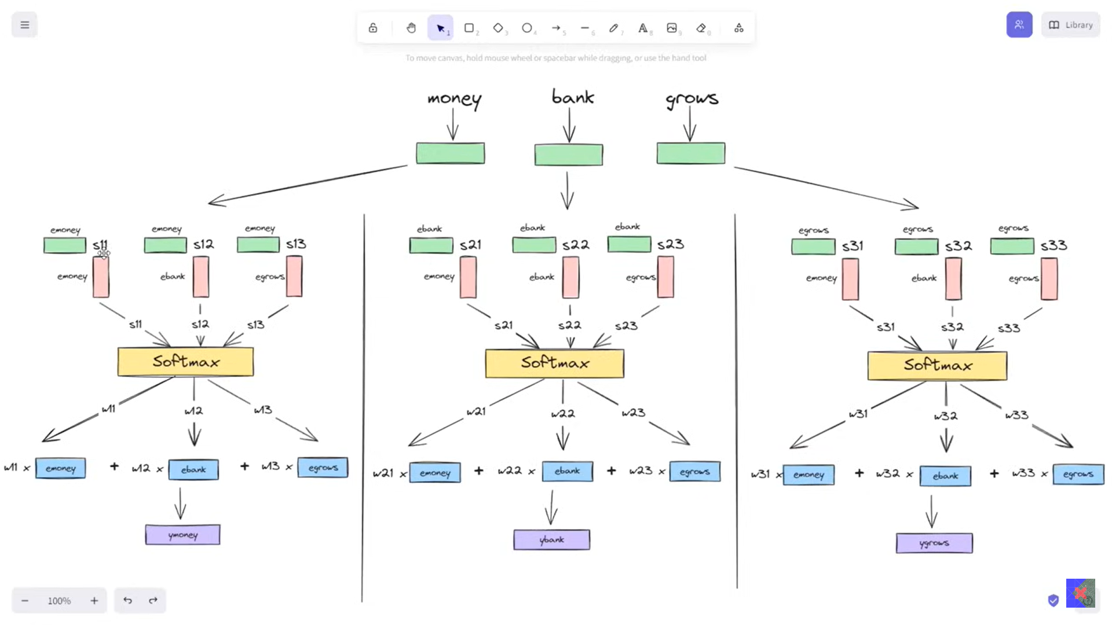
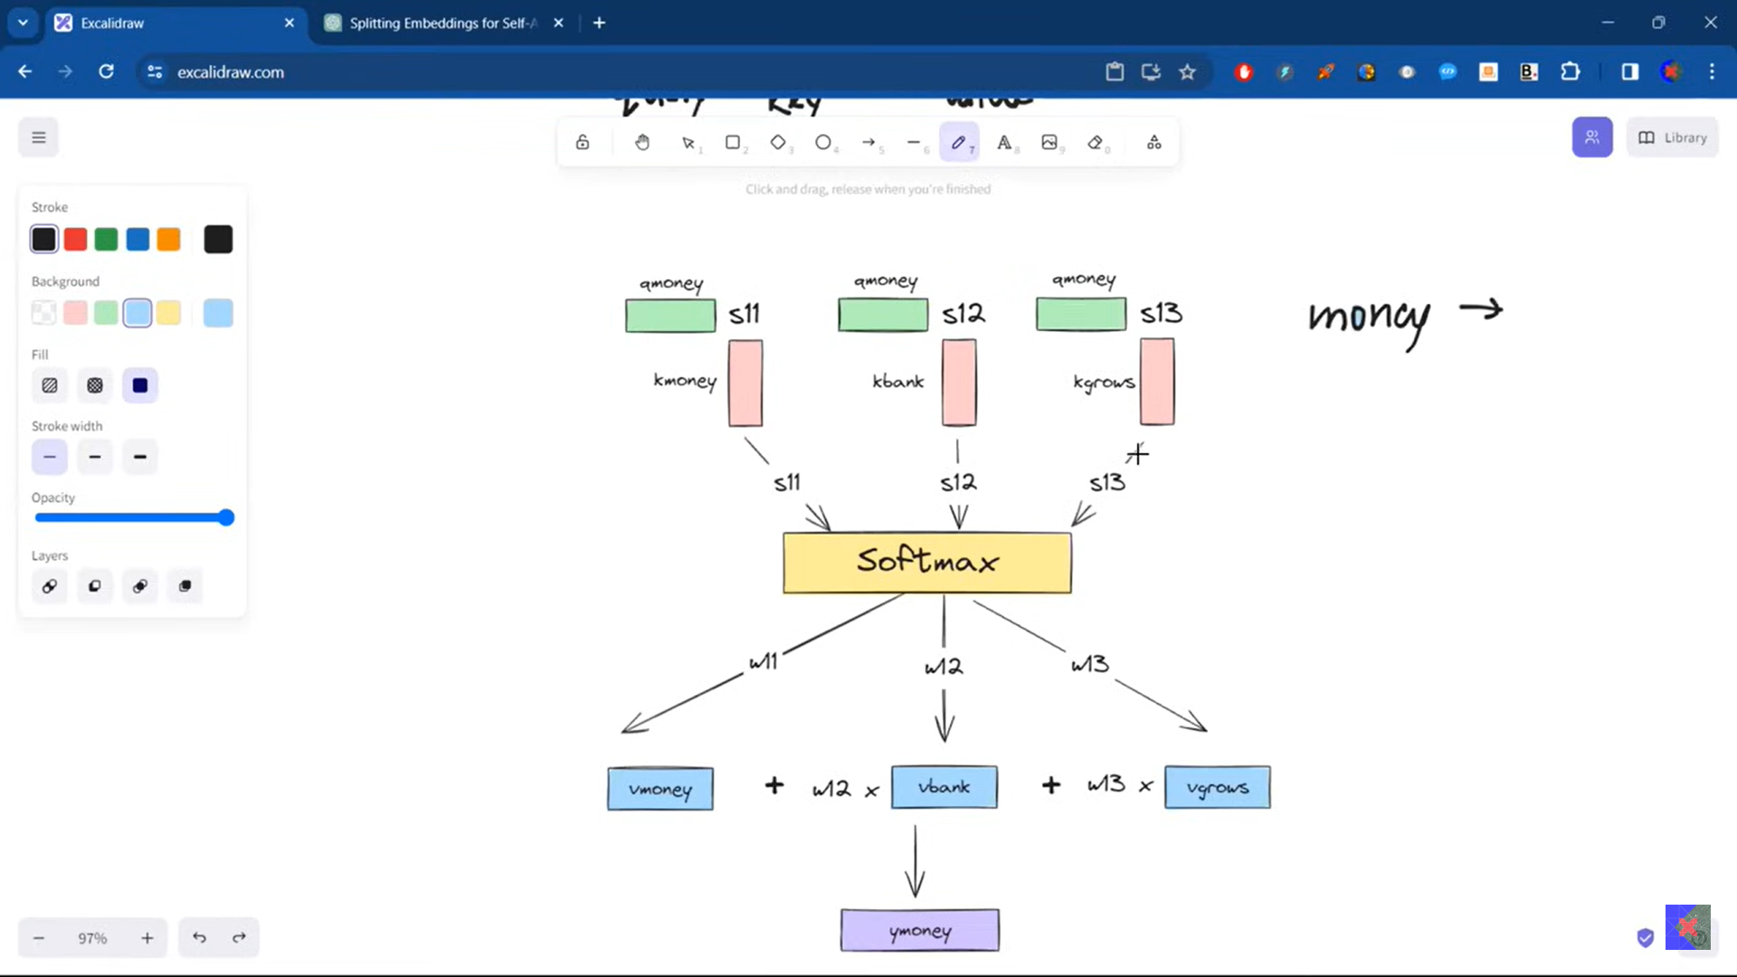
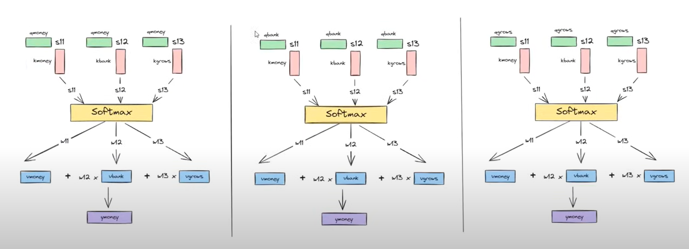


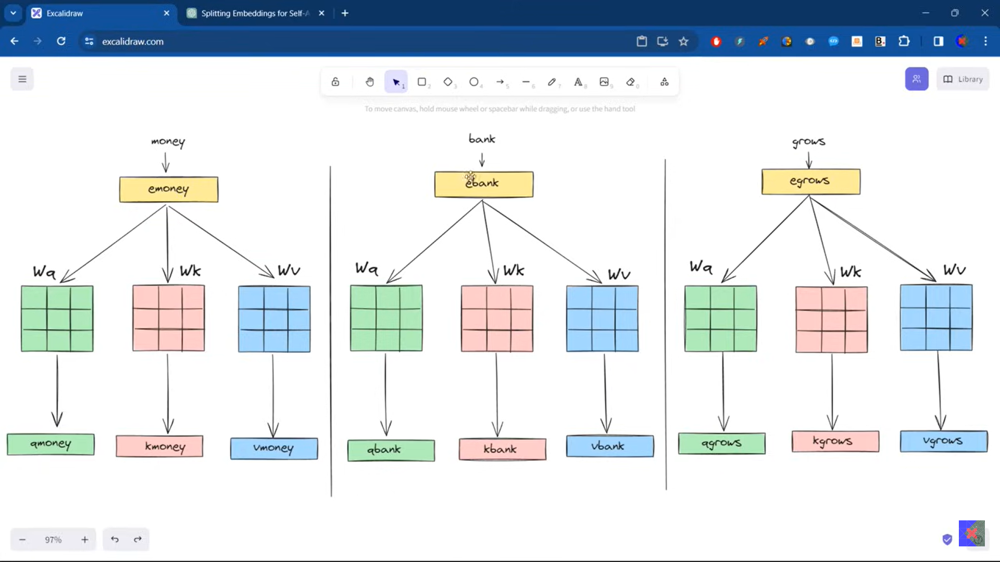
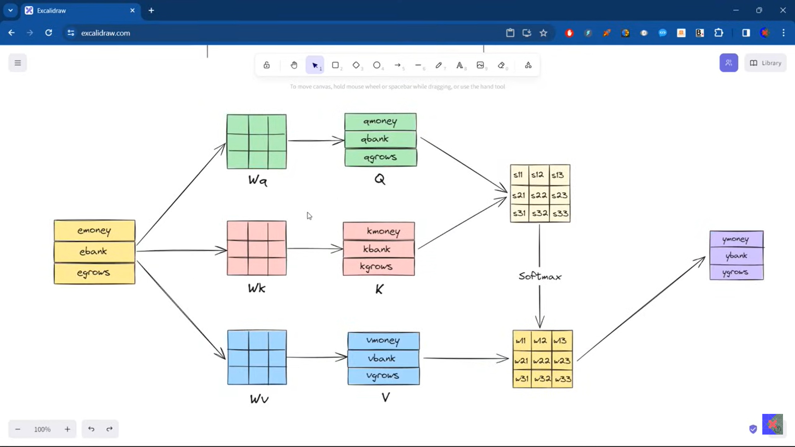
Parallel operation is also here in self attention

Self Attention in Transformers | Deep Learning | Simple Explanation with Code!
Parallel operation is also here in self attention

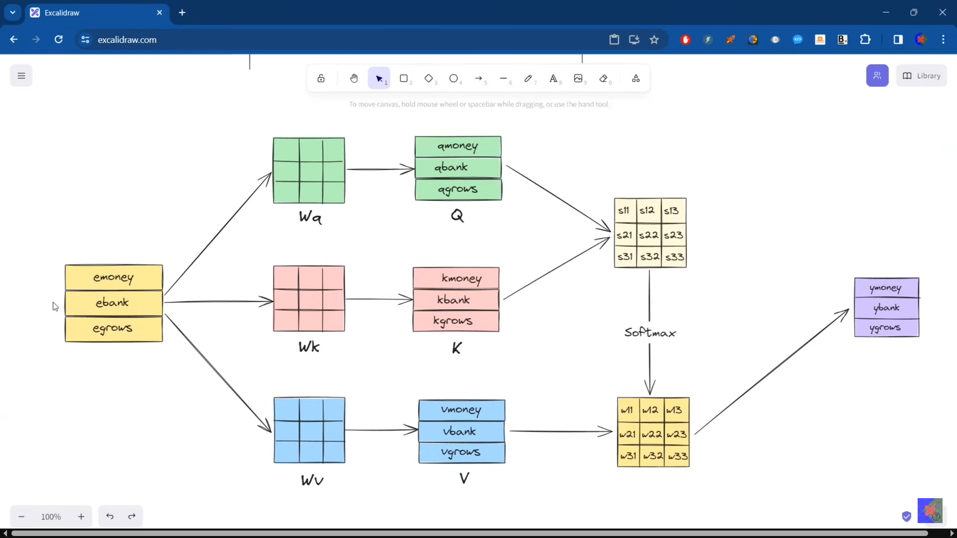
Scaled Dot Product Attention | Why do we scale Self Attention?
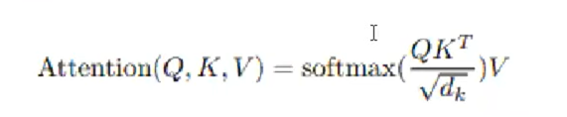
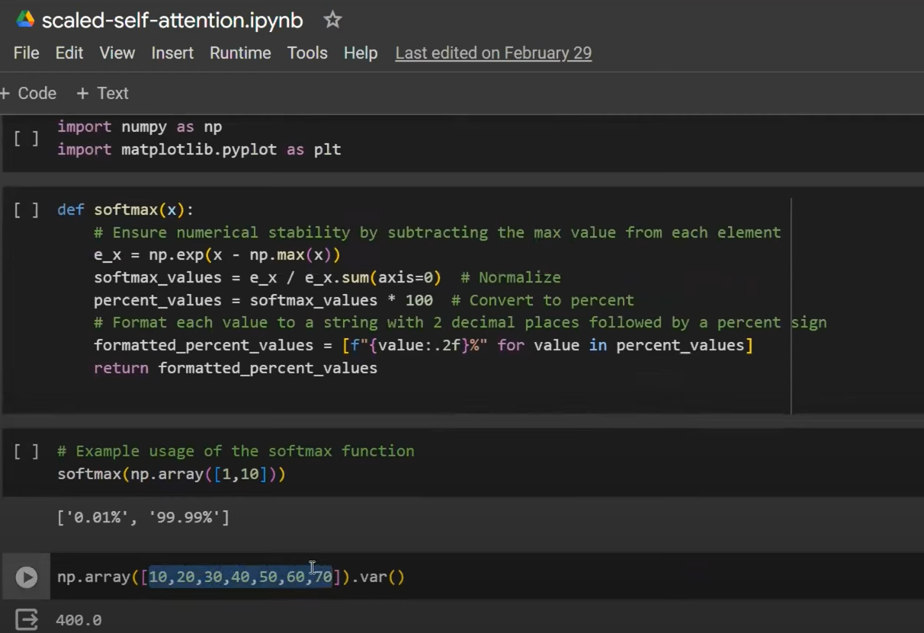
Greater number has high variance while small has lesser.

Self Attention Geometric Intuition | How to Visualize Self Attention | CampusX
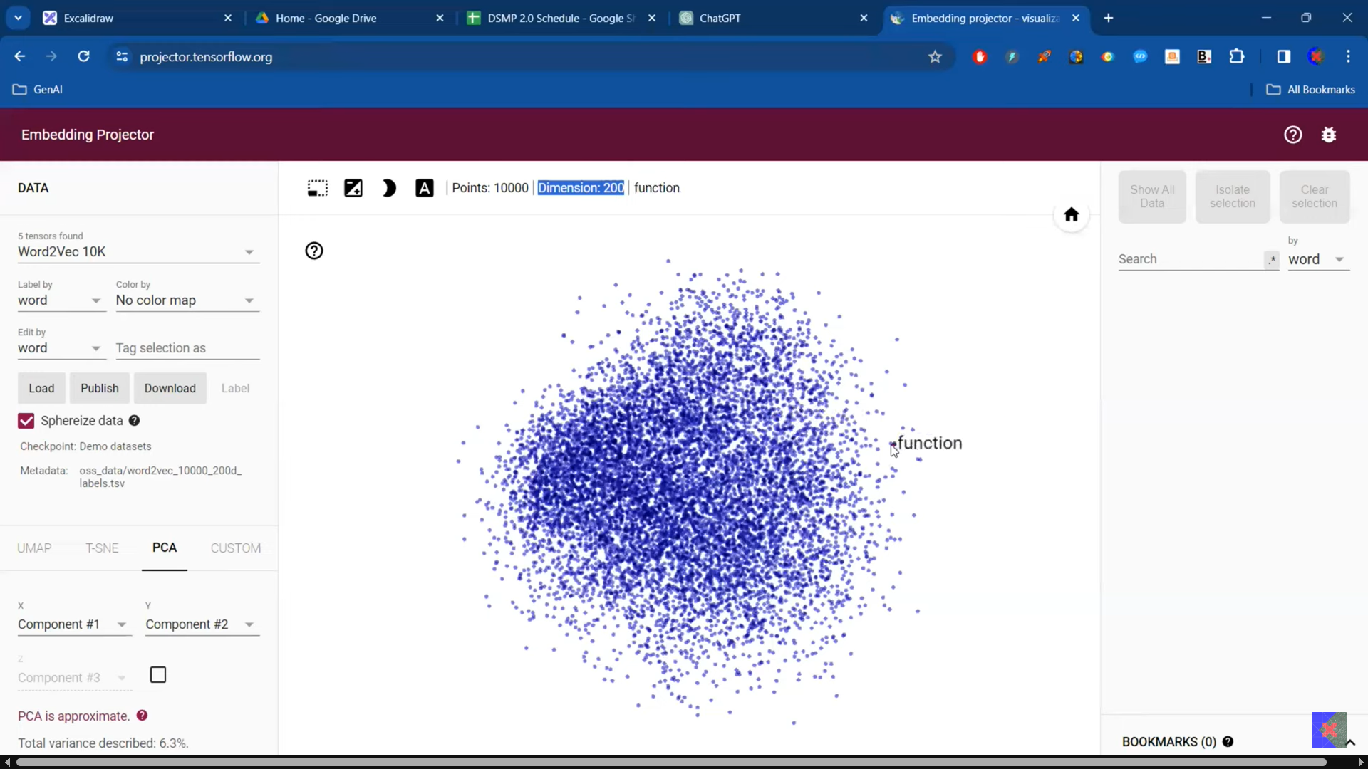
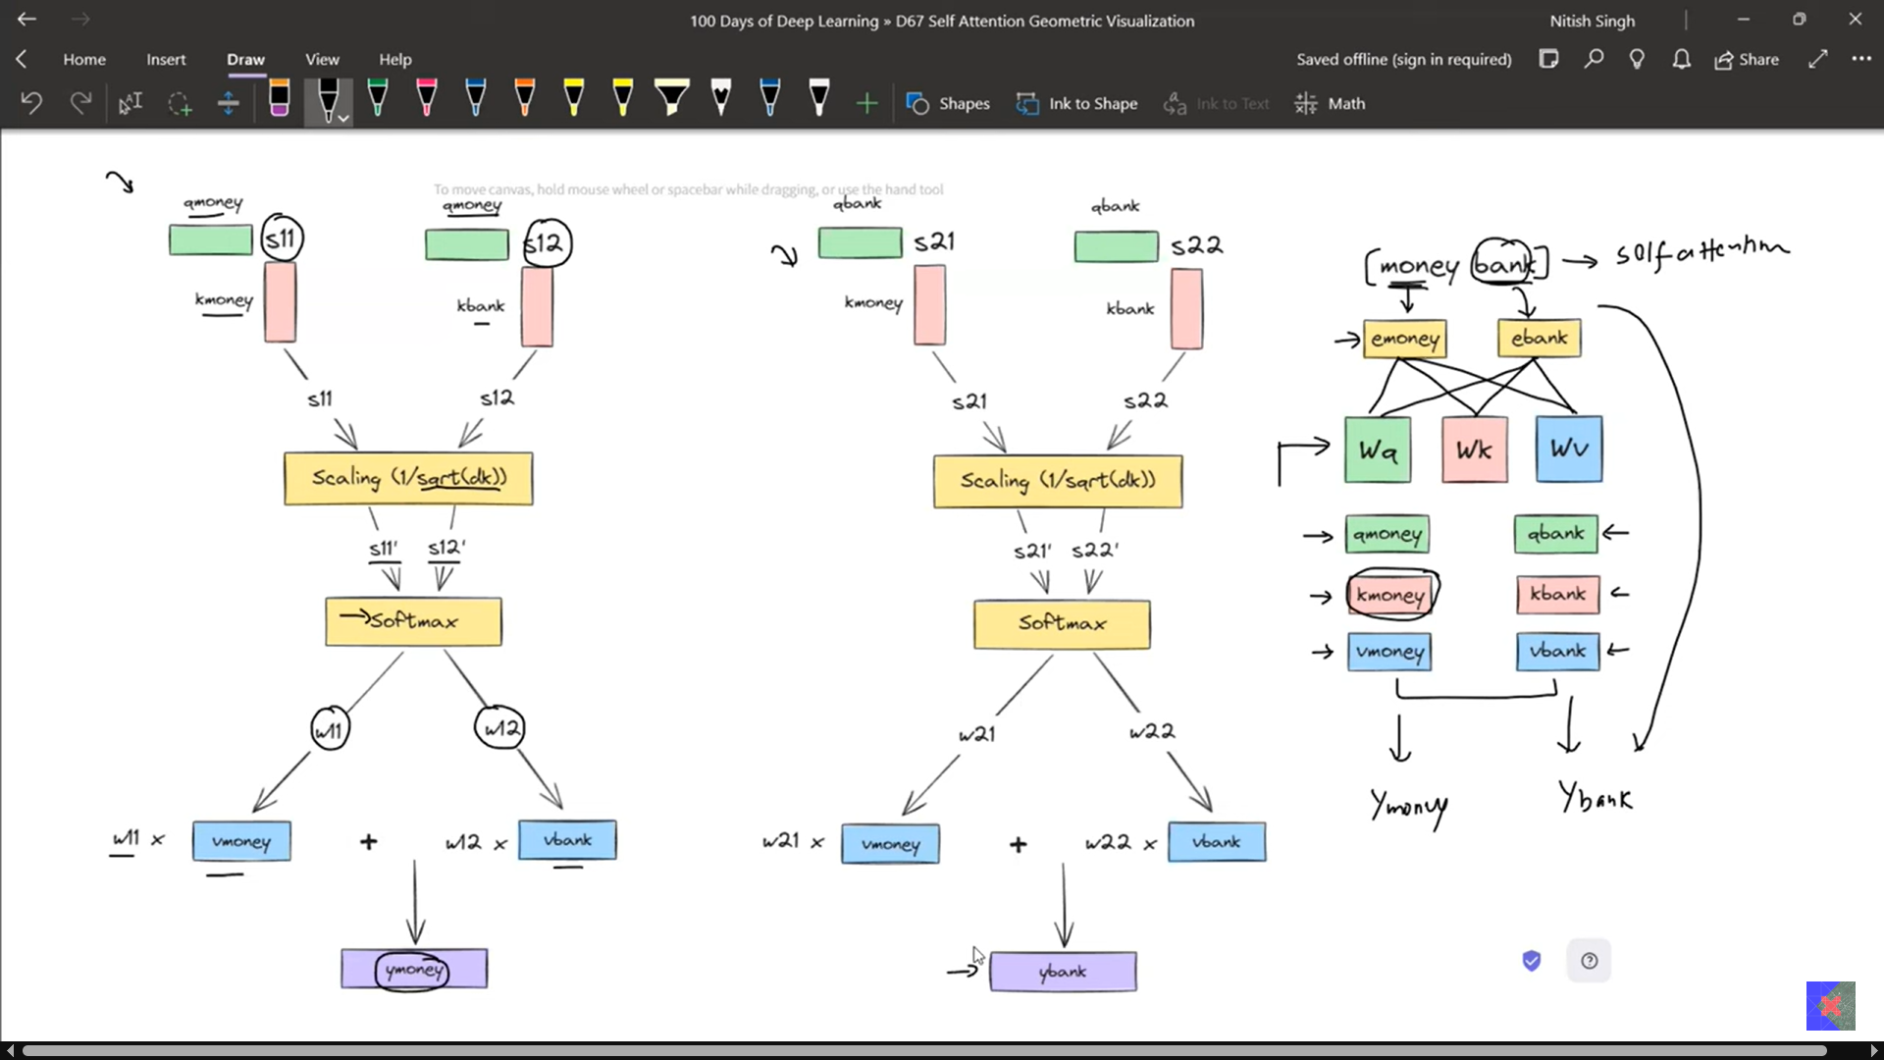
Why is Self Attention called "Self"? | Self Attention Vs Luong Attention in Depth Lecture | CampusX
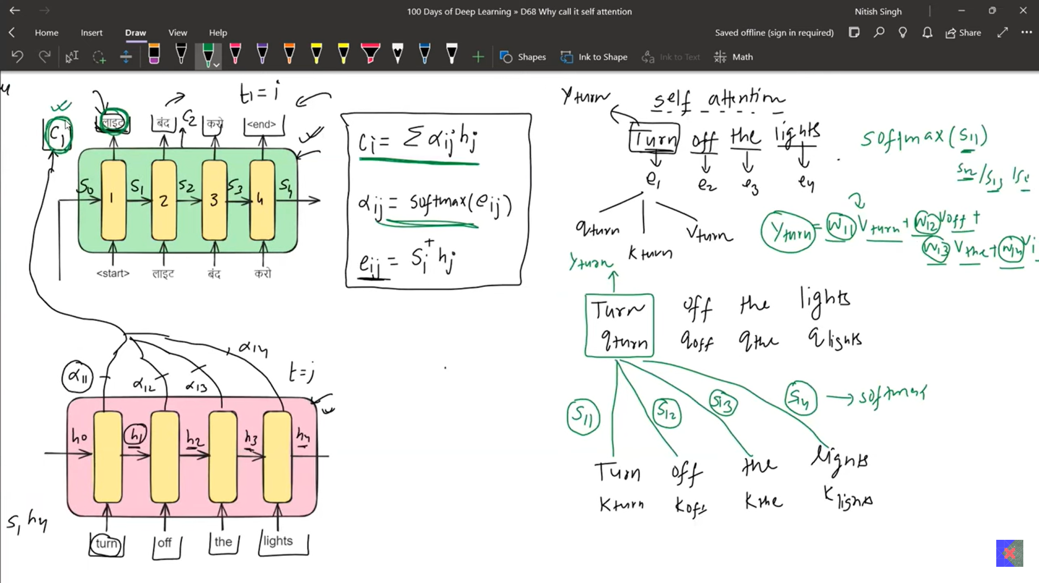

What is Multi-head Attention in Transformers | Multi-head Attention v Self Attention | Deep Learning
Viz Tool - https://colab.research.google.com/dri...
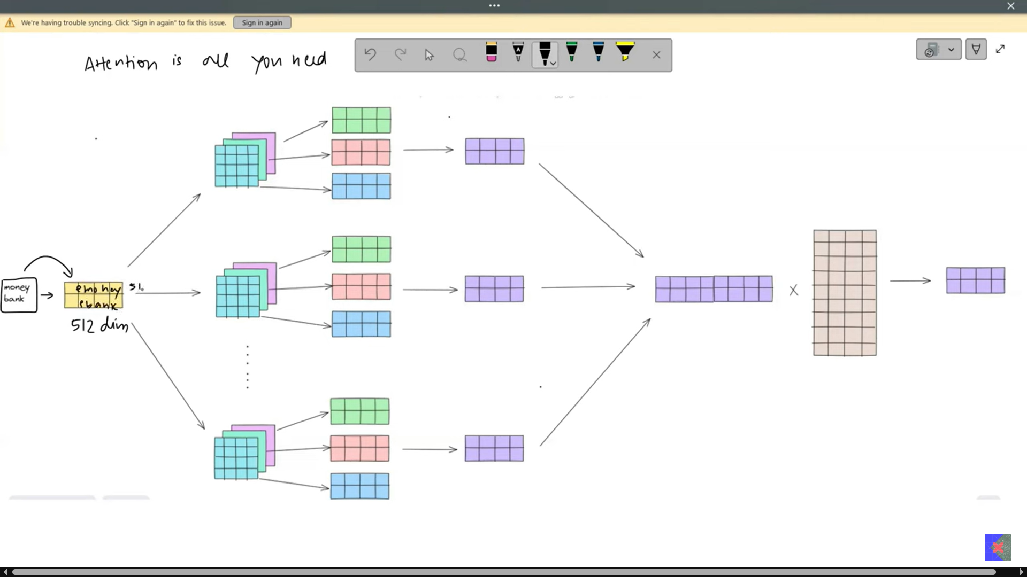
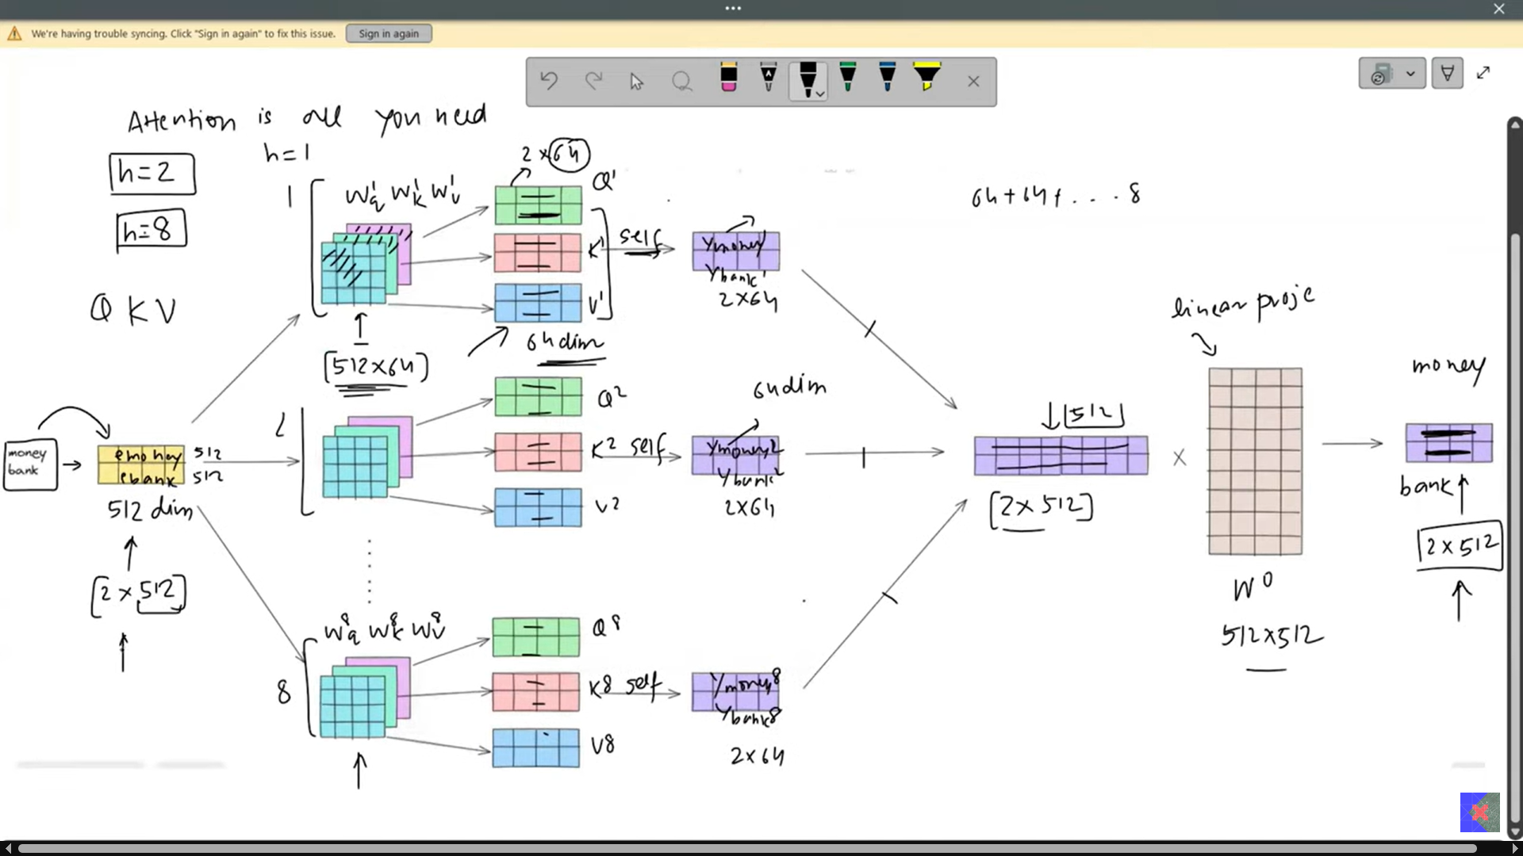
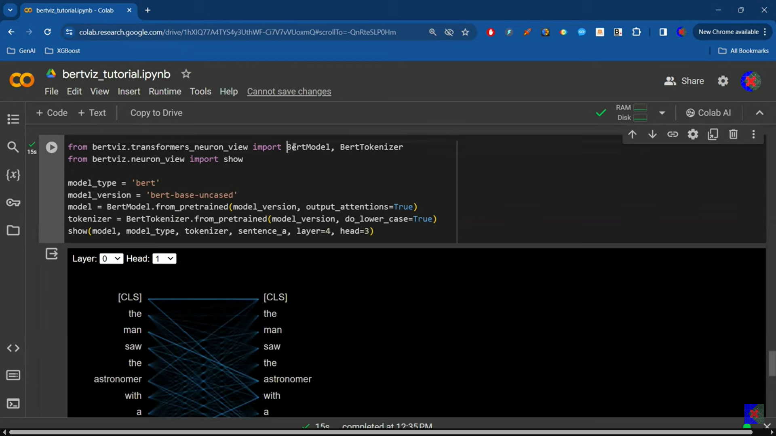
Do this practical link below
Viz Tool - https://colab.research.google.com/dri...

Positional Encoding in Transformers | Deep Learning | CampusX
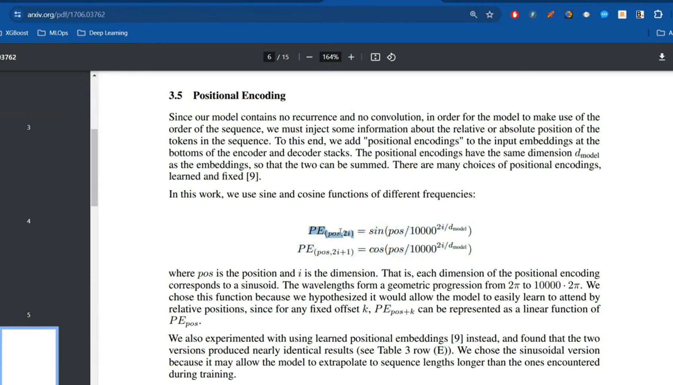
Blog link - https://blog.timodenk.com/linear-rela...

Layer Normalization in Transformers | Layer Norm Vs Batch Norm
Transformer Architecture | Part 1 Encoder Architecture | CampusX
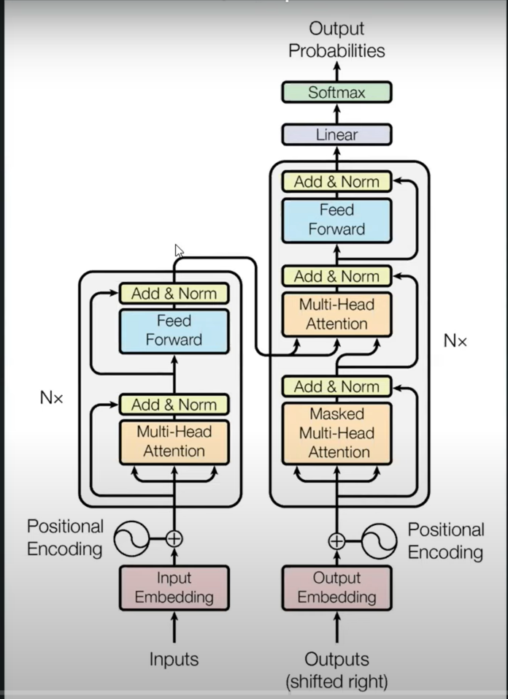
Check below research paper.
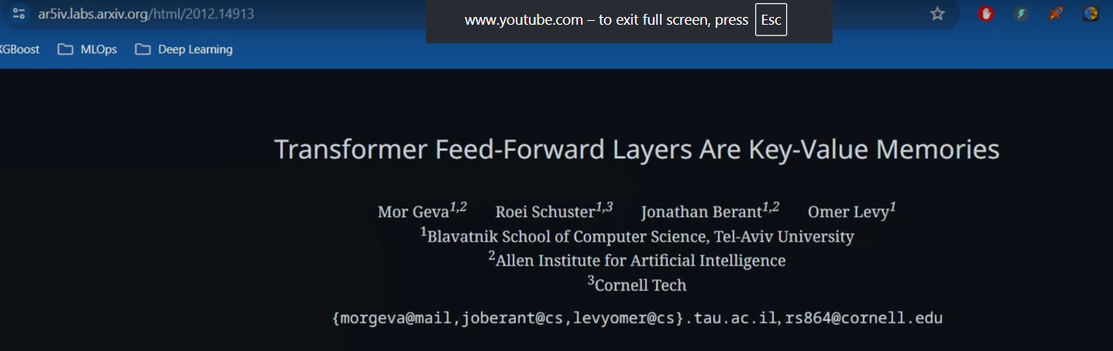
Masked Self Attention | Masked Multi-head Attention in Transformer | Transformer Decoder
Cross Attention in Transformers | 100 Days Of Deep Learning | CampusX
Transformer Decoder Architecture | Deep Learning | CampusX
Transformer Inference | How Inference is done in Transformer? | Deep Learning | CampusX

